Project Design Phase-II
Technology Stack (Architecture & Stack)

Date | 25 June 2026
Team ID
Project Name | RK-HEALTH
Maximum Marks | 4 Marks

Technical Architecture:
The Deliverable shall include the architectural diagram as below and the information as per the table1 & table 2
Technical Architecture of RK-HEALTH (Smart Patient Appointment & Medication Reminder System):
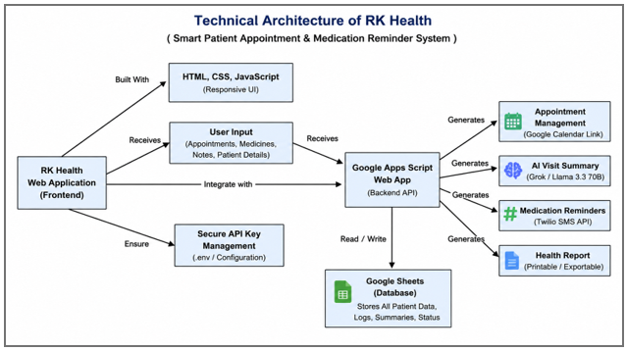

Table-1 : Components & Technologies:
S.No | Component | Description | Technology
1 | User Interface | How user interacts with application — responsive SPA with glassmorphism design, 3D background, dark mode | HTML5, CSS3, JavaScript (ES6+), Three.js r128, Font Awesome 6
2 | Application Logic-1 | Frontend application logic — state management, auth, CRUD operations, rendering, chatbot engine | JavaScript (ES6+), localStorage API, DOM manipulation
3 | Application Logic-2 | AI Chatbot Engine — symptom extraction, follow-up questions, specialist mapping, diet plan generation | JavaScript (rule-based + Groq AI API integration)
4 | Application Logic-3 | Backend server — REST API for AI, SMS, Calendar, Google Sheets proxy | Python 3.13, Flask, Flask-CORS, Gunicorn
5 | AI Model | Large Language Model for conversations, summaries, and health guidance | Groq Cloud API (LLaMA 3.3-70B-versatile) / Ollama (local fallback)
6 | Database (Client) | Client-side persistence for offline-capable demo mode | Web localStorage API (key-value, JSON)
7 | Database (Cloud) | Cloud data persistence for live mode | Google Sheets via Google Apps Script (GAS) REST API
8 | File Storage | Static assets and deployment artifacts | GitHub Pages (CDN hosting) / Render.com disk (backend)
9 | External API-1 | AI Inference — power chatbot, summary generation, and health guidance | Groq API (groq.com) — LLaMA 3.3-70B model
10 | External API-2 | SMS Notifications — medication and appointment reminders | Twilio SMS API (send messages to patient phone numbers)
11 | External API-3 | Calendar Integration — generate Google Calendar event links | Google Calendar API (URL-based event creation, no OAuth needed)
12 | External API-4 | Cloud Data Sync — sync localStorage to Google Sheets | Google Apps Script (REST endpoint deployed as web app)
13 | Infrastructure (Frontend) | Static site hosting with HTTPS, CDN, custom domain support | GitHub Pages / Cloudflare Pages / Netlify
14 | Infrastructure (Backend) | Python server hosting for Flask backend services | Render.com / Railway / PythonAnywhere (Gunicorn + Flask)

Table-2: Application Characteristics:
S.No | Characteristics | Description | Technology
1 | Open-Source Frameworks | Frontend: None (vanilla HTML/CSS/JS). Backend: Flask (BSD), Flask-CORS. 3D: Three.js (MIT). Icons: Font Awesome (MIT). | Flask, Three.js, Font Awesome
2 | Security Implementations | Role-based access control (3 roles). Input sanitization in chat. API keys in separate config file (config.js). No session cookies (localStorage based). CORS enabled for backend. Environment variables for production keys. | CORS, role-based auth, input validation
3 | Scalable Architecture | 3-tier architecture: (1) Frontend SPA on CDN, (2) Flask REST API on cloud server, (3) Serverless AI API. Each tier scales independently. Frontend is stateless, backend is horizontally scalable with Gunicorn workers. | 3-tier architecture, stateless frontend, Gunicorn workers
4 | Availability | Frontend on GitHub Pages (99.9% uptime). Backend on Render.com with auto-recovery. Works fully offline in demo mode via localStorage. Graceful degradation when APIs are unavailable. | GitHub Pages CDN, Render.com auto-deploy, offline fallback
5 | Performance | Groq AI responses in <1 second (fastest LLM API). Static assets served via CDN. localStorage operations are synchronous and instant. Three.js uses GPU acceleration. CSS animations at 60fps. No server-side rendering bottlenecks. | Groq Cloud (fast inference), CDN, GPU-accelerated 3D

References:
https://c4model.com/
https://developer.ibm.com/patterns/online-order-processing-system-during-pandemic/
https://www.ibm.com/cloud/architecture
https://aws.amazon.com/architecture
https://medium.com/the-internal-startup/how-to-draw-useful-technical-architecture-diagrams-2d20c9fda90d

